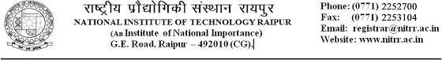

NITRR/ECED/2025 Date:28/04/2025

To,

The Director,

Electricity Training Institute, Sarojini Nagar,

Lucknow, Uttar Pradesh

Subject :- “Industrial Internship Program”- B.Tech – Electronic and communication Engineering.

Dear Sir/Madam,

In order to provide experimental learning and exposure to various industrial practices ,the students are encouraged to take up “industrial internship program” for a duration of 4 weeks between 5th June to 2nd July, 2025.

In this regard I request you to provide internship to Ms.Riya Kasaudhan, enrollment no- 221131, Student of B.Tech(3rd year) in the department of electronic and communication Engineering.

Industrial internship is a part of our curriculum and is required for partial fulfilment of the course. Your assistance in providing industrial internship will be highly appreciated.

Regards

Dr.Toshan Lal Meenpal HOD

Dept, of Electronic and Communication Engineering NIT Raipur.